1. Statistics relating to the government ethics units’ work of handling criminal cases
Month | Illegality Other than Corruption Sent Out | Illegality Other Than Corruption Sent for Other Agencies | Corruption Cases Followed With Administrative Penalty | Illegality Other than Corruption  Followed With Administrative Penalty | Reported Case Handled Administratively | Reported Case Clarified And Closed
Jan | 62 | 12 | 35 | 68 | 497 | 155
Feb | 25 | 5 | 18 | 24 | 275 | 102
March | 58 | _ | 87 | 75 | 616 | 236
April | 38 | _ | 39 | 55 | 406 | 122
May | 20 | 3 | 25 | 30 | 326 | 105
June | 98 | 6 | 91 | 63 | 549 | 176
July | 15 | 3 | 35 | 32 | 457 | 151
August | 24 | 2 | 11 | 32 | 205 | 114
Sept. | 16 | _ | 2 | 42 | 99 | 120
Oct. | 78 | 5 | 45 | 42 | 416 | 133
Nov. | 84 | _ | 15 | 25 | 332 | 172
Total | 518 | 36 | 403 | 488 | 4,178 | 1,586
2. Statistics relating to the government ethics units’ anti-corruption work
Work Type | Item |  |  | No. of Cases
Anti-Corruption Research | Special Report (Qualitative Research) |  |  | 35
Anti-Corruption Research | Anti-Corruption Survey Report (Quantitative Research) |  | Self-Handled | 338
Anti-Corruption Research |  |  | Outsourced | 60
Anti-Corruption Research | Corruption Prevention Guide |  |  | 10
Anti-Corruption Research | Benefit: No. of Cases Suggested Be Accepted |  |  | 353
Suggestions For Improvement of Operations | Seminar |  |  | 195
Suggestions For Improvement of Operations | Inspection |  |  | 5,610
Suggestions For Improvement of Operations | Prevention Measures |  |  | 602
Suggestions For Improvement of Operations | Rectification of Shortcoming |  |  | 5,622
Auditing of Operations | No. of Cases Handled |  |  | 2,880
Auditing of Operations | No. of Cases of Illegality Unearthed |  |  | 39
Auditing of Operations | No. of Cases Suggested Be Accepted |  |  | 1,620
Procurement Comprehensive Analysis | No. of Procurement Comprehensive Reports |  |  | 1,578
Procurement Comprehensive Analysis | No. of Cases Passed To Judicial Agency |  |  | 219
Procurement Comprehensive Analysis | No of Monitored Cases | On-Spot Monitoring |  | 72,053
Procurement Comprehensive Analysis | No of Monitored Cases | Written Monitoring |  | 51,480
Participation of Society | Directed At Enterprises And Suppliers | No. of Sessions |  | 696
Participation of Society | Directed At Enterprises And Suppliers | No. of Participants |  | 124,867
Participation of Society | Directed At Private Groups And General Public | No. of Sessions |  | 2,146
Participation of Society | Directed At Private Groups And General Public | No. of Participants |  | 2,201,771
Participation of Society | Directed At Students And Teachers | No.of Sessions |  | 1,763
Participation of Society | Directed At Students And Teachers | No. of Participants |  | 212,338
Anti-Corruption Education And Training | Ethics Code Promotion | No. of Sessions |  | 4,333
Anti-Corruption Education And Training | Ethics Code Promotion | No. of Participants |  | 476,621
Anti-Corruption Education And Training | Other Anti-Corruption Promotional Work | No. of Sessions |  | 2,355
Anti-Corruption Education And Training | Other Anti-Corruption Promotional Work | No. of Participants |  | 395,062
Anti-Corruption Education And Training | No. of Registered Cases according to Ethics Code | Received Gratuities |  | 16,690
Anti-Corruption Education And Training | No. of Registered Cases according to Ethics Code | Hospitality |  | 10,134
Anti-Corruption Education And Training | No. of Registered Cases according to Ethics Code | Entreating/Lobbying |  | 16,429
Anti-Corruption Education And Training | No. of Registered Cases according to Ethics Code | Other Ethics Incidents |  | 2,015
Anti-Corruption Education And Training | Number of Integrity Models Commended |  |  | 2,820
Anti-Corruption Education And Training | Number of Integrity and Competence Rewarded |  |  | 3,131

3. 2010 statistics surrounding government employee property declaration cases and the random investigations into veracity.

No. of Declarations Received | No. of Cases Selected For Actual Examination via Public Drawing of Lots | Cases Actual Examined As Percentage of Total | No. of Cases Subject to Previous and Following Year Comparison | Percentage of Drawing
53724 | 7884 | 14.68% | 1418 | 18%

4. Statistics surrounding those government employees’ property declarations cases that are false or delayed.

Unit: Case, NT$10,000
Month | No. of Cases Examined | Penalized Cases |  |  | Cases of Illegality |  |  | Amount of Penalty
Month | No. of Cases Examined | Overdue Declaration | Deliberate False Declaration | Total | Justifiable Reason For Overdue Declaration So No Penalty Imposed | Non- Deliberate False Declaration | Total | Overdue Declaration | Deliberate False Declaration | Total
Jan. | 45 | 0 | 27 | 27 | 1 | 17 | 18 | 0 | 85.4 | 85.4
Feb. | 50 | 0 | 15 | 15 | 0 | 35 | 35 | 0 | 33.5 | 33.5
March | 102 | 1 | 29 | 30 | 1 | 71 | 72 | 2 | 211 | 213
April | 44 | 2 | 24 | 26 | 0 | 18 | 18 | 15 | 72 | 87
May | 48 | 2 | 19 | 21 | 1 | 26 | 27 | 126 | 498 | 624
June | 0 | 0 | 0 | 0 | 0 | 0 | 0 | 0 | 0 | 0
July | 0 | 0 | 0 | 0 | 0 | 0 | 0 | 0 | 0 | 0
August | 39 | 2 | 16 | 18 | 1 | 20 | 21 | 8.9 | 69.8 | 78.7
Sept. | 38 | 0 | 15 | 15 | 2 | 21 | 23 | 0 | 78 | 78
Oct. | 0 | 0 | 0 | 0 | 0 | 0 | 0 | 0 | 0 | 0
Nov. | 0 | 0 | 0 | 0 | 0 | 0 | 0 | 0 | 0 | 0
Total | 366 | 7 | 145 | 152 | 6 | 208 | 214 | 151.9 | 1047.7 | 1199.6
5. Statistics surrounding recusal of public servants due to conflicts of interest.
Unit:Case. NT$10,000
Time(Time) | Total Number Of Cases Examined | Penalized Cases |  | Non-Penalized Cases | Cases Requiring Re-Examination | Cases Where Original Penalty Cancelled
Time(Time) | Total Number Of Cases Examined | No. of Cases | Amount | Non-Penalized Cases | Cases Requiring Re-Examination | Cases Where Original Penalty Cancelled
First Time (Fe. 17, 2011) | 7 | 4 | 541 | 2 | 1 | 0
Second Time (June 1, 2011) | 8 | 2 | 110 | 1 | 2 | 3
Third Time (June 16, 2011) | 1 | 0 | 0 | 1 | 0 | 0
Fourth Time (Aug. 8, 2011) | 2 | 1 | 100 | 1 | 0 | 0
Total | 18 | 7 | 751 | 5 | 3 | 3

6. An analysis of AAC newly received malpractice cases
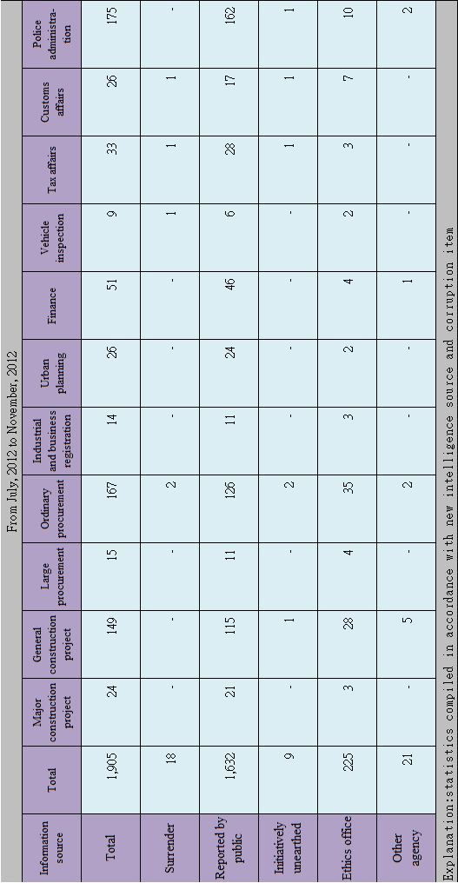

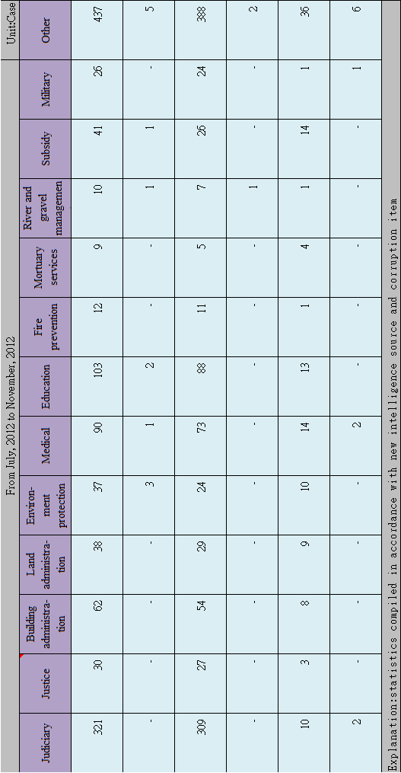
7. The circumstances surrounding corruption investigation intelligence handled by AAC
1. Relying upon information sources
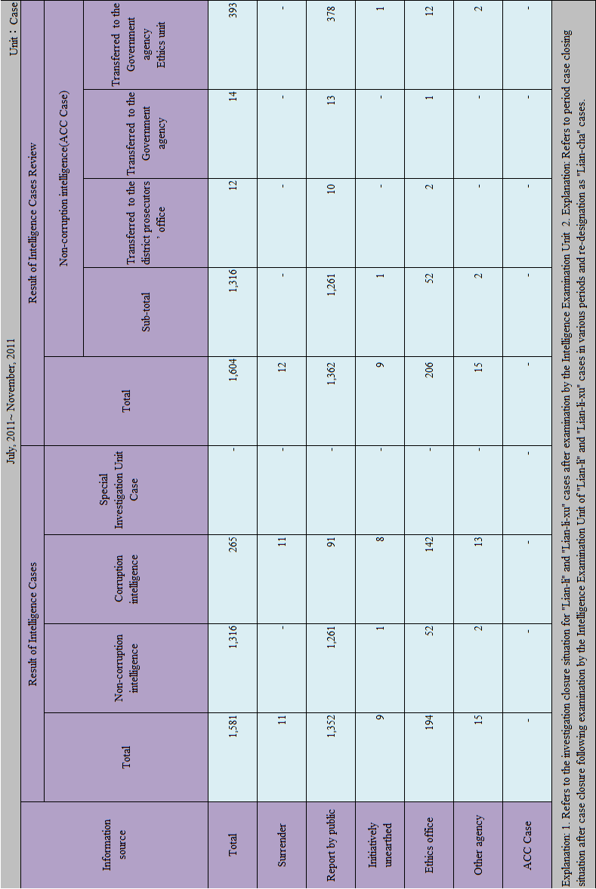
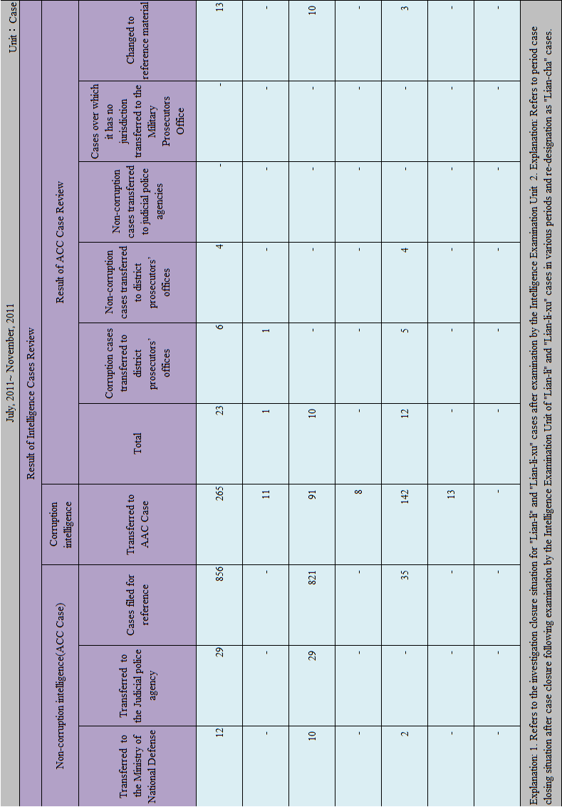
2. Relying upon malpractice items
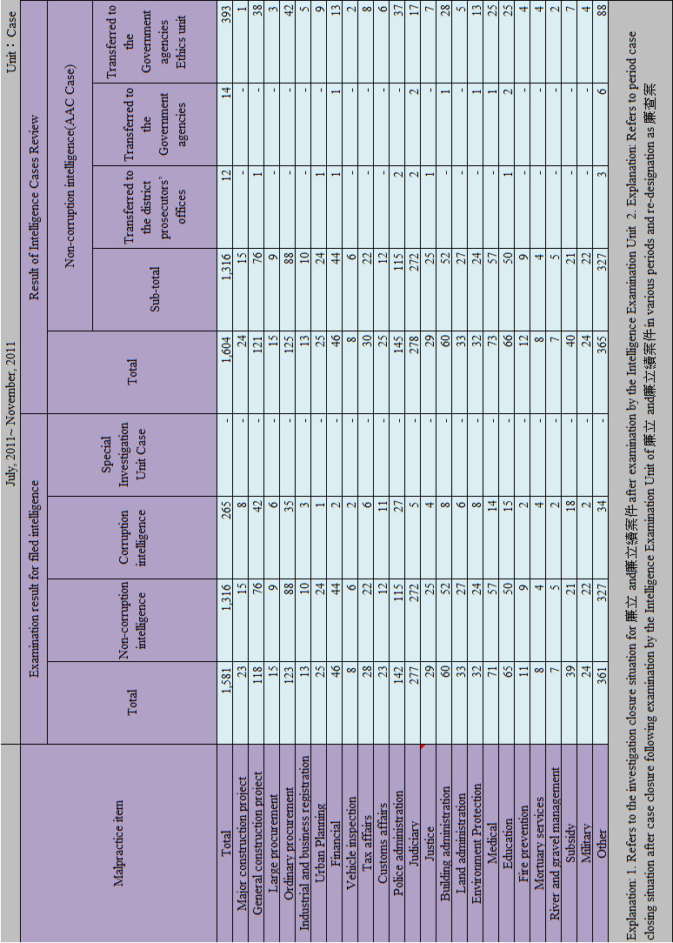

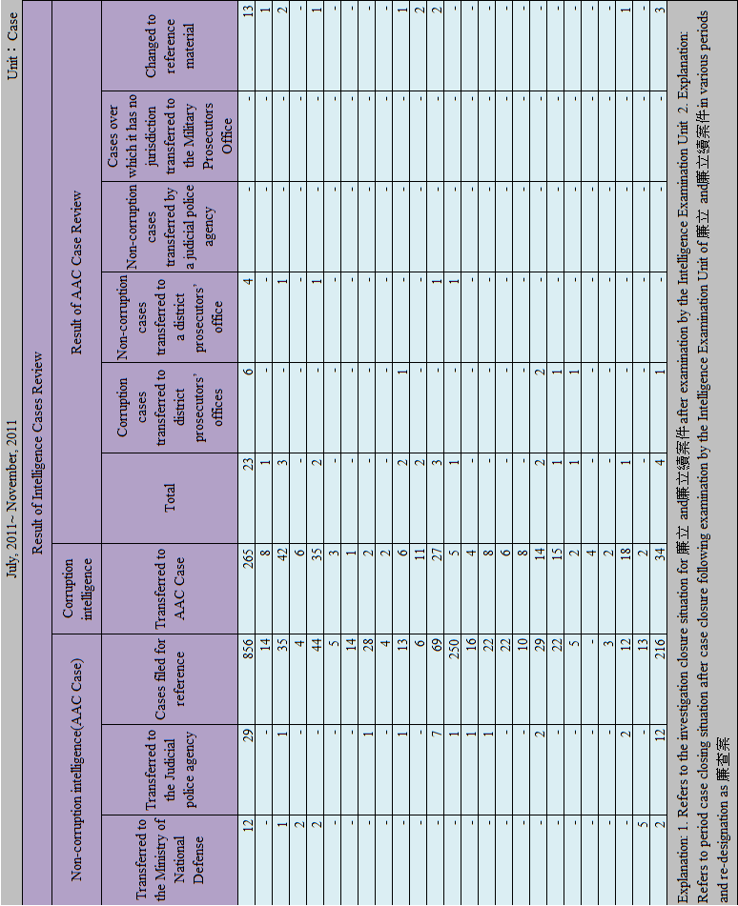

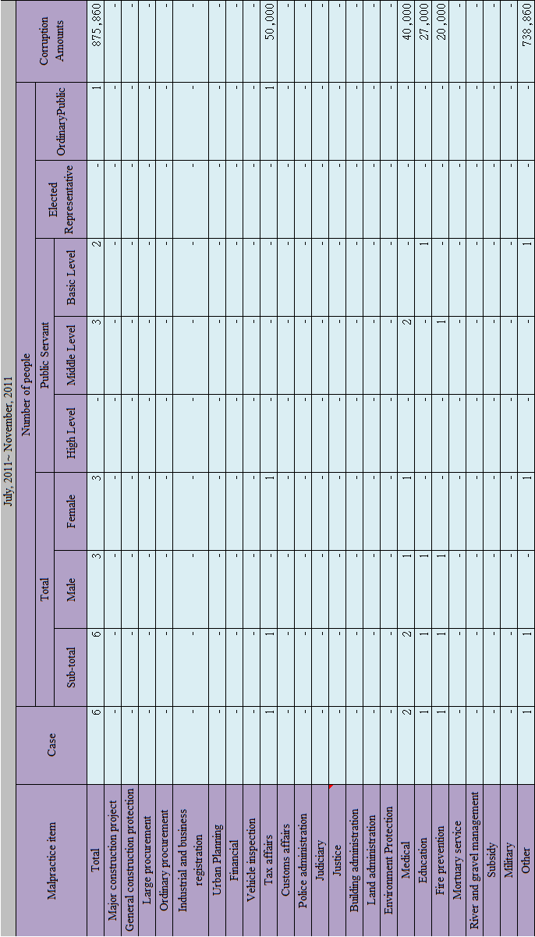
8. Circumstances surrounding cases of suspected crimes transferred from AAC on to the administering district prosecutor’s offices
9. Circumstances surrounding the conclusion of those suspected corruption cases passed from AAC to the administering district prosecutor’s offices
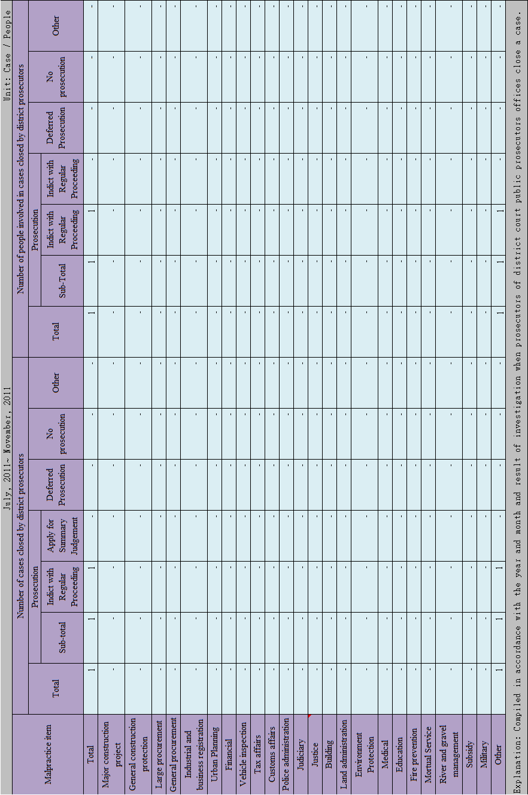
10. Statistics related to the distribution of monetary rewards for reporting illegality
Year | Cases Examined | Reward Paid | No Reward Paid | Decision Postponed | Amount Of Reward Paid (NT$)
2011 First Time | 15 | 10 | 4 | 1 | 9,466,669
2011 Second Time | 6 | 3 | 2 | 1 | 4,216,666
Total | 21 | 13 | 6 | 2 | 1,2266,669
11. Statistics of investigative cases inspected by Clean Politics Advisory Committee
 | Meeting Date | Cases Filed for Reference
 | Meeting Date | Start And End Date | Number of Cases Examined
First Meeting | Oct 13, 2011 | July 26-Sept 8, 2011 | 566
Second Meeting | Dec. 8, 2011 | Sept. 9-Oct 31, 2011 | 267

12. Statistics for international exchanges in the work clean politics
Meeting/Observation Mission | The Third Senior Officials’ Meeting of the APEC Anti-Corruption and Transparency Experts Task Force, ACT | Meeting of the APEC Pharmaceutical Sector Business Ethics Experts Working Group | APEC Construction and Engineering Sector Business Ethics Experts Working Group | Mission To Observe Anti-Corruption Operations in Sweden
Date | Sept. 12-26, 2011 | Sept. 26-28, 2011 | Oct. 5-7, 2011 | Oct. 29 To Nov. 7, 2011
Participants | The AAC’s Head Prosecutor Zhang Jing-Wen And Prosecutor Yu Zhi-Qing | The AAC’s Head Prosecutor Zhou Huai-Lian | The AAC’s Officer Fan Yi-Kai | The AAC’s Section Chief Chen Chun-Hsin and Executive Officer Nie Wen-Juan
Place | San Francisco, USA | Mexico City, Mexico | Hanoi, Vietnam | Sweden
Main Points Of Discussion/Handling Situation | The AAC dispatched personnel to attend the APEC ACT meeting; in addition to presenting an oral report about the progress of the anti-corruption work in Taiwan, through discussions with attending members an understanding of the key points ACT’s annual anti-corruption work and the implementation situation of UNCAC (United Nations Convention against Corruption) in APEC economies was obtained. | Representatives from industry, government and academia of the APEC economies attended this meeting and discussed the Mexico city principles- code of business ethics for the biopharmaceutical sector. The meeting’s conclusions and suggestions were approved at the APEC Leaders’ meeting held on Nov.10-12 in Honolulu, USA, and it is hoped that the competent agency or anti-corruption competent agency in the APEC and economies will help promote and implement this code. | Representatives from industry, government and academia of the APEC economies attended this meeting and discussed the Hanoi principles - code of business ethics for the construction and engineering sector. The meeting’s conclusions and suggestions were approved at the APEC Leaders’ meeting held Nov.10-12 in Honolulu, USA, and it is hoped that the competent agency or anti-corruption competent agency in the APEC and economies will help promote and implement this code. | This mission visited the ombudsman of the Swedish parliament, the National Development Committee, the Swedish prosecution authority, the anti-corruption association and Stockholm city government to acquire an understanding of Sweden’s anti-corruption system, regulations and their operating mechanism implementation situation to provide reference when the AAC plans anti-corruption policy , system and carries out corruption prevention and elimination work, and, through the visit, strengthen exchange between Sweden and ROC in the area of clean government and Sweden’s understanding of the roc’s anti-corruption efforts.

